Content BL Report
Content BL Report is centered on the completion of documents that represent company’s portfolio offers.
The report is sourced using APIs data and is represented by the following tables:
- BL_API_content_transformation - r
- Assets_API_content_transformation - r
- Index_BL_content_transformation - r
Additional datasets
- Last Refresh Table
- RLS
Relationships
Table (column) | Relationship | Table (column) | Status
BL_API_content_  transformation- r (url) | Cardinality:  Many to Many  Cross-filter direction: Both | Assets_API_content_  transformation - r  (name) | Active
BL_API_content_  transformation- r (main_entity) | Cardinality:  Many to Many  Cross-filter direction: BL_API filters RLS | RLS | Active

Data model
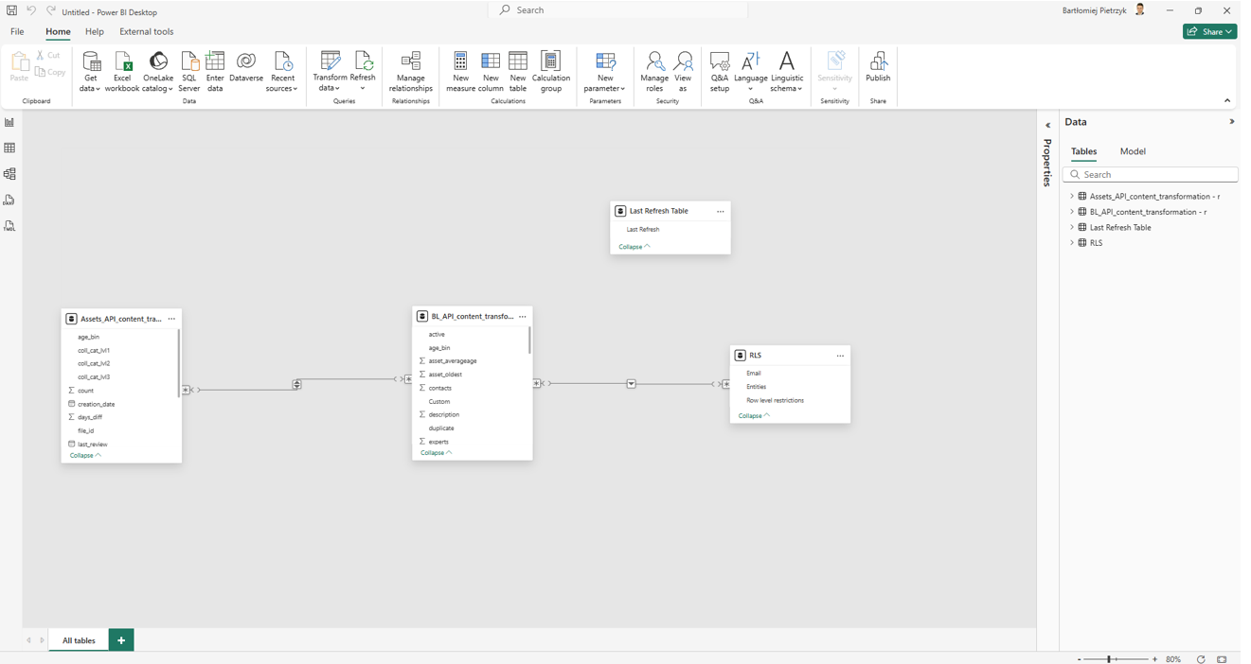

Dataflow architecture
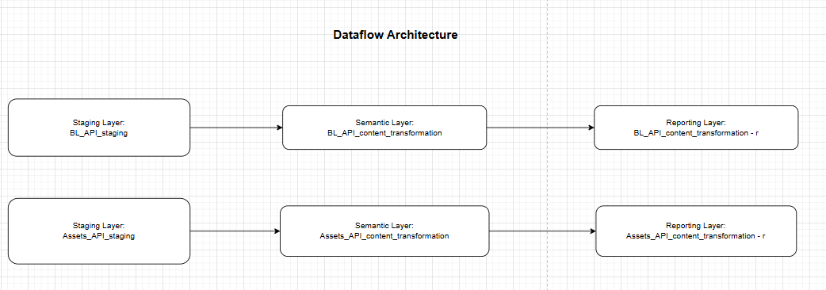

Summary
- BL_API_content_transformation - r table is joined with Index_BL_content - r to meet further reporting hierarchical needs.
- BL_API_content_transformation - r joined with Assets_API_content_transformation - r and transformed for further reporting needs.
- RLS – an excel file with the content needed to meet row-level security for specific users according to their business lines.
Core functionalities
- Hierarchy
  - Company’s offers are displayed on the website using a hierarchical structure. To replicate this functionality in Power BI, Index table was created to identify offers categorized as core entities. Each of these core entities is then used to generate the corresponding drop-down lists in the report.
- Columns of the API represent offers content, business-specific data used to calculate the overall score for each individual offer.
- Bottom diagram represents overall target score for documents completion for core/main entities
Visual representation
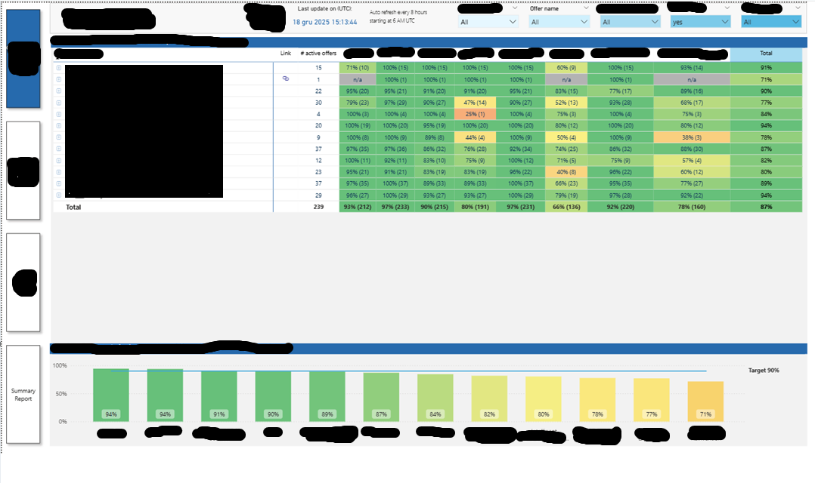
Semantic model creation process
On blank report, I import tables from Datamart.
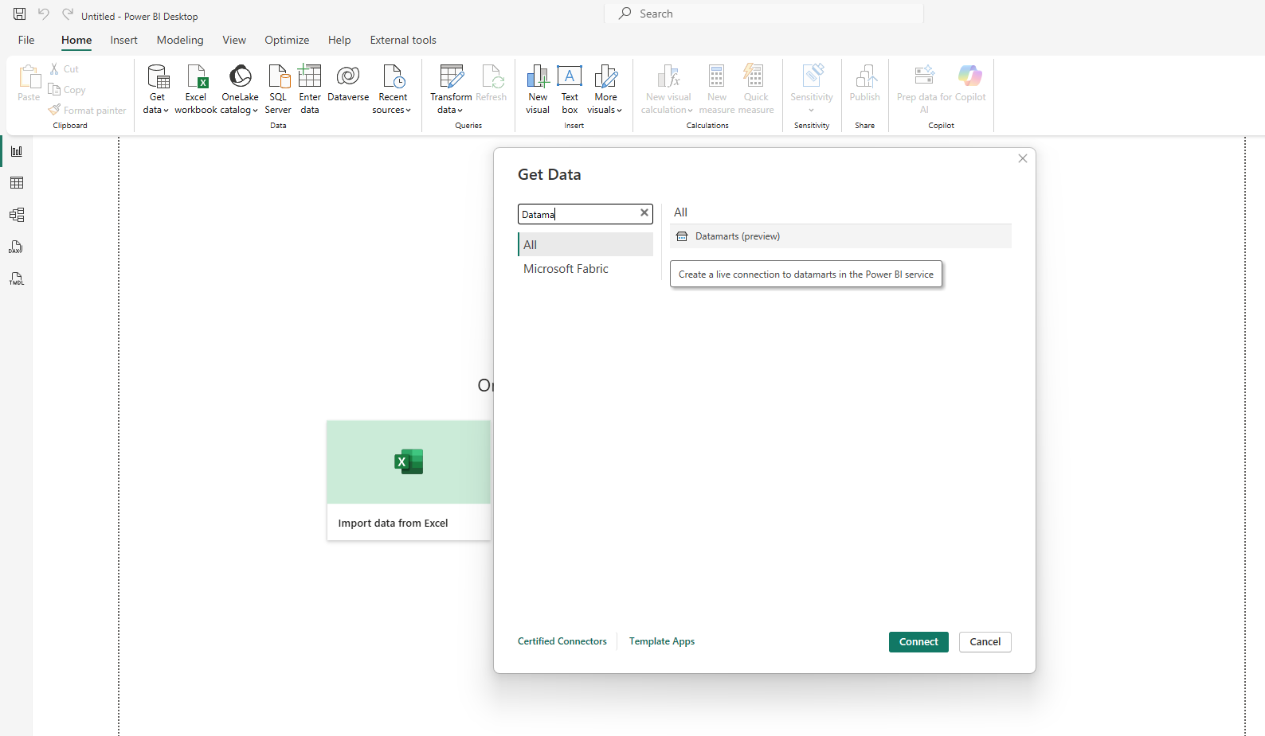

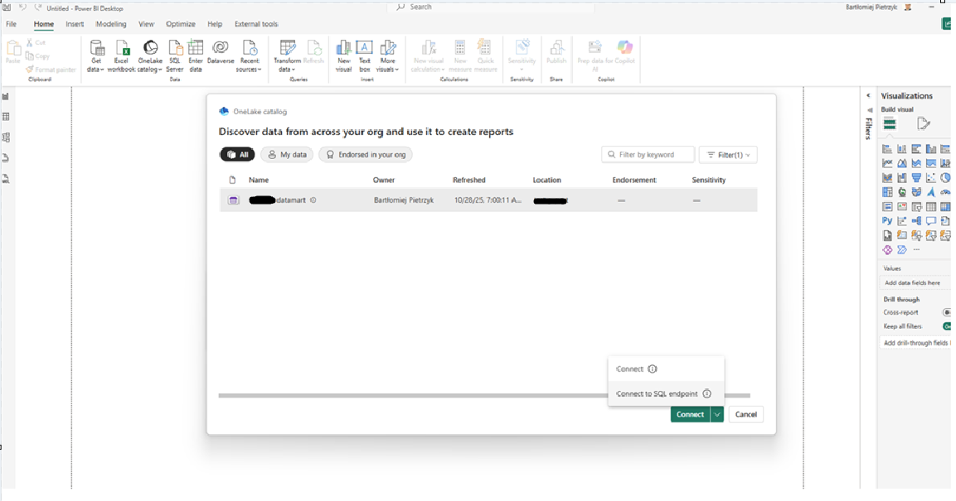
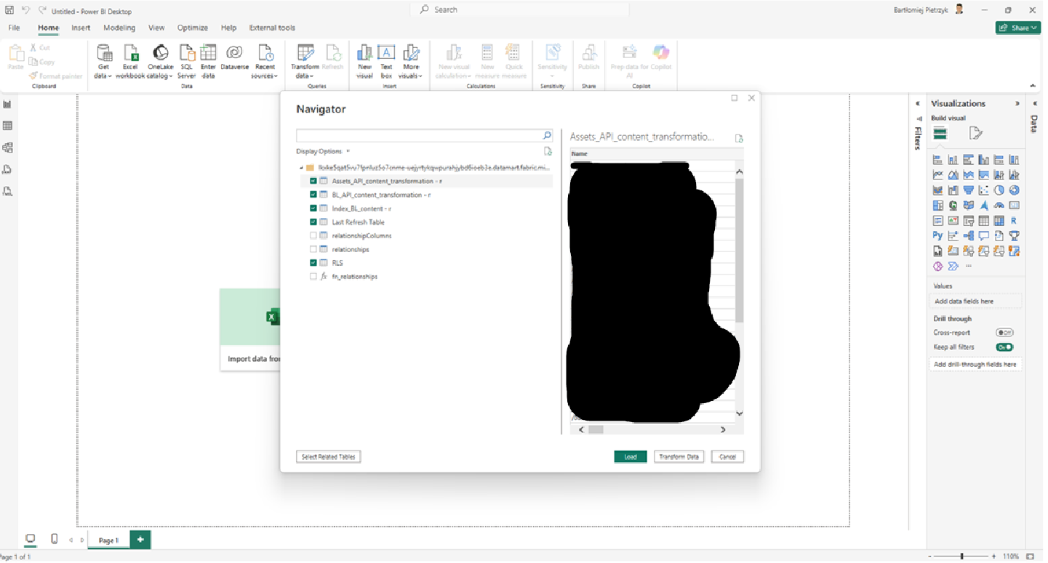
Click on “Transform Data” -> Import Connection settings
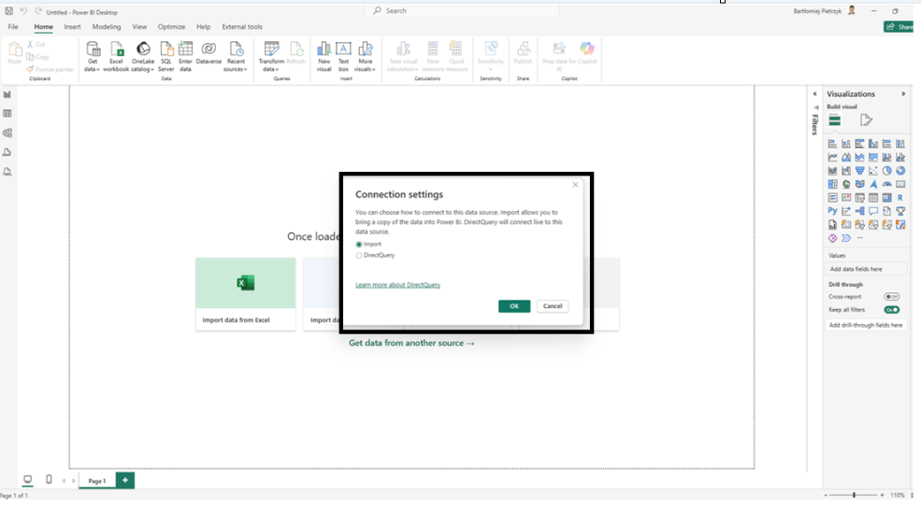
Disable load for Index_BL_content – r
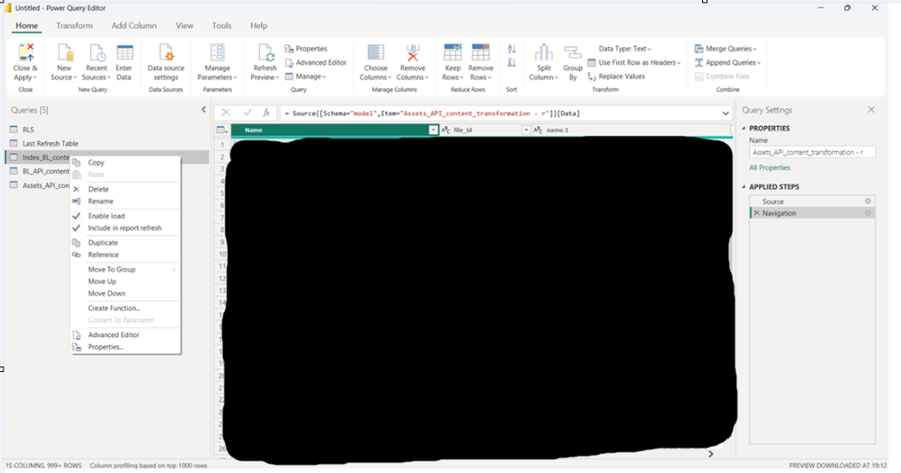

Creating relationships
